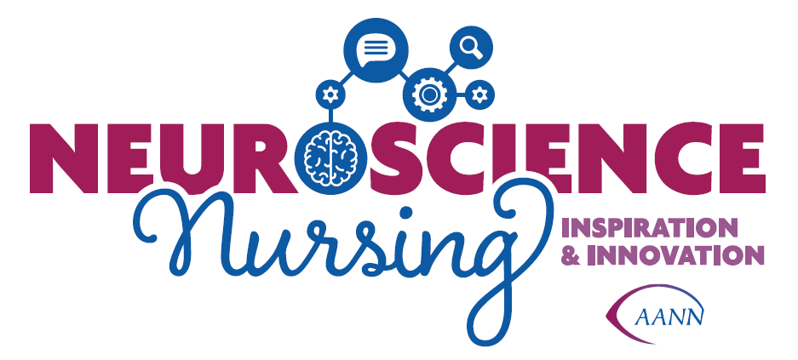

Neuroscience Nurses Week
WHEREAS, the people of <your state> are concerned with meeting the healthcare needs of <your state>’s population; and
WHEREAS, neuroscience nurses are a vital and indispensable component in the safety and quality of patient care; and
WHEREAS, neuroscience nurses make a positive contribution to healthcare in <your state>; and
WHEREAS, patients rely on the skills, knowledge and expertise of neuroscience nurses who have a tradition of working toward patient safety and improving the quality of patient care; and
WHEREAS, more quality neuroscience nurses will be needed in the future to meet the increasingly complex needs of health care consumers in this community and in the state.
NOW, THEREFORE, I, <Governor>, Governor of the State of <your state>, do hereby urge all citizens to take due note of the observance of May 11-17, 2025 as Neuroscience Nurses Week.
IN WITNESS WEREOF, I
have hereunto set my hand
and caused the Great Seal of
the State of <state> to be
affixed at <capitol>, the
Capitol, this <day> day of
<month>, in the year two
thousand twenty four.
<Governor Signature>

