2026 Activity Planning Guide

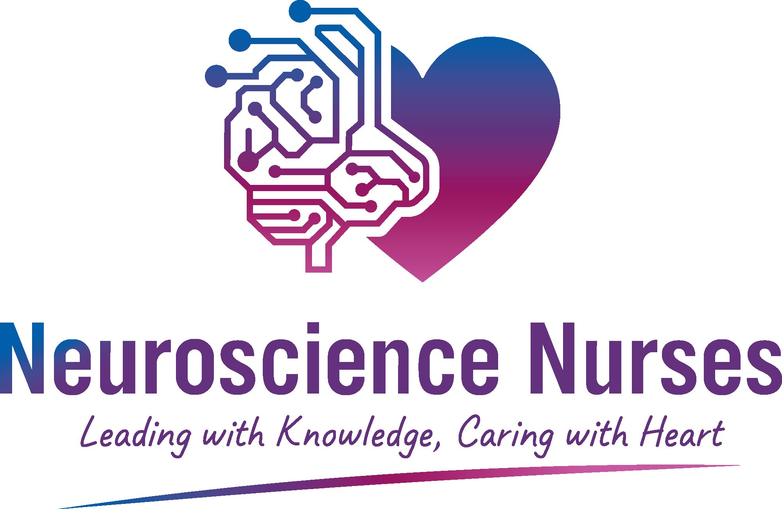

Dear Neuroscience Nurses Week Celebrator:
Thank you for participating in AANN’s Neuroscience Nurses Week! We hope you find it truly rewarding and successful.
Neuroscience Nurses Week celebrates the work of neuroscience nurses and highlights their influence on patient care. As a nursing professional, you understand how critical neuroscience nurses are in creating the best healthcare outcomes possible. But many people within your facility and in the community at large may not have a full understanding of your role. Neuroscience Nurses Week activities are designed to increase awareness and strengthen staff, community and patient relations.
AANN has created this activity booklet to assist you in planning a neuroscience nursing recognition program. Use this guide to help spread the word about Neuroscience Nurses Week in your facility and your entire community!
Your active participation in this special week is important to you and your facility, as well as to the long-term recognition of the profession. We encourage you to share this booklet with members of your staff so that everyone can celebrate the vital role of neuroscience nurses and help plan and implement this exciting event.
Thank you for your commitment to spreading the word about neuroscience nursing through Neuroscience Nurses Week!

The American Association of Neuroscience Nurses (AANN)

Target Audiences
Keep the following target audiences and supporters in mind when you choose your Neuroscience Nurses Week activities. Plan events during this week to recognize these special individuals. Applaud your distinguished team members or use promotional pieces to spread the word about the efforts made throughout the year during Neuroscience Nurses Week.
Hospital Administration
What better time to highlight the activities and accomplishments of your department to your CEO, hospital administrator, nursing administrator and other top administrative staff? Neuroscience Nurses Week provides an opportunity to increase community awareness of your facility.
Medical Staff
Good communication and cooperation with your medical staff are essential in providing quality healthcare. Let your key physicians know how much you appreciate their support by recognizing those who have made a significant contribution to your neuroscience nursing program.
Nursing Staff
Use this week to recognize the support of the nursing staff while increasing and enhancing communication between your nursing staffs.
Your Department Staff
Spotlight your employees for their significant job performance. As neuroscience nursing ambassadors for the hospital, they deserve special recognition beyond an annual performance review. Use National Neuroscience Nurses Week to let them know how much you understand the unique contribution they make to the effective operation of the hospital and showcase those staff members who do an outstanding job.
The Community
Use this week to spread the word and make a lasting impression in the community about who you are and what you do on behalf of the hospital and its patients. This is a valuable public relations opportunity that is not always available to the hospital. Use it to your best advantage.

Special Events
Enhance your department’s image, both internally and externally, through special events. The following pages will give you some ideas about what you can do to increase exposure and heighten awareness about neuroscience nursing. Many of these suggestions are based on other facilities’ successful Neuroscience Nurses Week activities. We hope that they generate additional original ideas!
Use the examples provided within this booklet to develop your own unique Neuroscience Nurses Week. Modify the suggestions here to suit your own environment and budget. Be creative and adapt the activities and quality messages to fit your own situation.
If your organization’s budget is tight and it is difficult to host a full week of activities, consider promoting Neuroscience Nurses Day. Special activities or recognition can take place any day of National Neuroscience Nurses Week.
We have provided a full week’s worth of sample activities. Beginning with a kick-off event and closing the week with a community outreach day. Read through the ideas carefully and formulate your own agenda of special recognition activities and events.

Remember to begin the publicity for your event early by contacting your hospital’s public relations department and hospital newsletter editor as soon as possible.

Day 1 – Kick-Off Event and Open House
Hold a special kick-off event that includes a ceremony and proclamation signing along with an open house.
Event Ideas and Checklist
- Contact the administration office for guidelines and approval of a kick-off event and open house 6-8 weeks prior to the event.

- Hold a special kick-off event with invited dignitaries, e.g., the mayor, the village president and hospital board members.

- Develop a brief opening ceremony with the reading or signing of the proclamation as the official kick-off of Neuroscience Nurses Week.

- Notify the hospital public relations department about the event in advance and coordinate with them to send out news releases and invitation to the local media 2 weeks prior to the event.

- Send invitations to the homes of the neuroscience nursing staff.

- Decorate various areas with Neuroscience Nurses Week posters and promotional items.

- Provide light snacks and refreshments, such as soda and cookies.

- Assign staff to develop colorful, eye-catching exhibits about various work of the department.

- Make arrangements for providing hospital tours and provide name tags for guests.

- Assign a photographer to take photos to send to the media and display at the hospital.

Post-Event Ideas and Checklist
- If media representatives did not attend, follow-up with a post-event news release and include photos from the event.
- Display color photos of the event on a highly visible bulletin board. Be sure to submit your favorite celebration photos to AANN staff, Allison Begezda (abegezda@aann.org).
- Submit a post-event article with photo to your hospital newsletter.

Day 2 – Employee and Volunteer Open House
Plan a department open house to introduce employees and volunteers to the neuroscience nursing department.
Event Ideas and Checklist
- Contact the hospital administration office for guidelines and approval of event 4-6 weeks prior to the open house.

- Contact the employee relations department and the newsletter editor to assist in publicizing the event internally.

- Arrange for refreshments or snacks. Be imaginative and rent a popcorn machine.

- Create an invitation using the Neuroscience Nurses Week logo. Send it to each department and request that they distribute it 2 weeks before the event.

- Create a flyer using the Neuroscience Nurses Week logo and images to announce an open house or post throughout your facility.

- Plan to utilize the exhibits that were created for and displayed at the Day 1 Open House.

- Arrange for someone to take photographs during your event.

- Assign team members to create a short true/false quiz about various departments. Award prizes to those who successfully complete the quiz.

- Assign team members to create a word-search puzzle or riddle about the departments and award prizes to those who successfully complete the puzzle.

- Have attendees sign in and drop their names into a bowl when they arrive and hold a raffle and give away prizes.

- Display your posters through the hospital all week.

Post-Event Ideas and Checklist
- Display photographs in various areas of the hospital.
- List the names of the people who attended the event in the internal newsletter thanking them for participating. Acknowledge the winners of the quiz, puzzle, riddle or raffle.

Day 3 – Patient’s Day
Let the patients in your hospital know you care by dedicating a day in their honor.
Event Ideas and Checklist
- Contact the administration offices for guidelines and approval 4-6 weeks prior to the Patient’s Day.

- Coordinate with the nursing unit managers to alert them to the date and time of patient’s visit.

- Contact the volunteer coordinator and request assistance of the hospital auxiliary and any other appropriate departments.

- Using the Neuroscience Nurses Week logo, print patient tray cards with a special message. Also display the cards on the tables in the dining room.

- Provide refreshments such as cookies and punch.

- Create 8 ½ x 11 Neuroscience Nurses Week coloring sheets using the logo and distribute to children in the hospital for a coloring contest.

- Display the posters colored by the children throughout the week.

- Decorate wheelchairs and nurse’s stations with balloons.

- Arrange for a photographer to capture the interaction.

Post-Event Ideas and Checklist
- Submit photographs to the hospital newsletter for a post-event story in the newsletter.
- Print patient tray cards with the logo thanking the patients for participating and celebrating neuroscience nursing.

Day 4 – Recognition Luncheon for Neuro Nurses
Salute the dedicated neuroscience nurses who make contributions throughout the year. Hold a special luncheon in their honor and present “Excellence in Neuroscience Nursing” awards.
Events Ideas and Checklist
- Coordinate with the administration office for guidelines and approval 4-6 weeks prior to the luncheon.

- Determine the budget and decide on the type of luncheon. Contact the food services manager for suggestions, or if money is tight, have a potluck themed lunch.

- Arrange for a room if you are not having the luncheon in your department.

- Invite the hospital administrator and other key management personnel as special luncheon guests.

- Recognize outstanding departments or individuals.

- Give your awards ceremony a name such as the “Reach for the Star Award” or “Showcase of Neuroscience Nursing.”

- Arrange for special recognition certificates to be given to staff members.

- Deliver bouquets of balloons to various departments.

- Provide carnations and buttons to all house and medical staff.

- Arrange for someone to take photographs of your event and special award-winners.

Post-Event Ideas and Checklist
- Send a post-event news release and photos to local media.
- Display photos from your event on a prominent bulletin board.
- Submit photos and an article to the hospital’s internal newsletter.

Day 5 – Community Outreach
Acquaint the community with your facility’s neuroscience nursing team. Provide plenty of opportunities for media coverage.
Event Ideas and Checklist
- Contact the administration office for guidelines and approval 10-12 weeks prior to the event.

- Establish a planning team 10-12 weeks prior to the event. Have a representative from several departments in your hospital serve on the team.

- Coordinate with the hospital’s marketing and community relations director to determine the internal and external publicity such as an article in the employee newsletter and news releases.

- Hold a community outreach event on the weekend to increase community participation and media coverage.

- Conduct hospital tours and offer free health screenings.

- Invite the local media to cover the event.

- Sent Neuroscience Nurses Week invitations to local schools, churches, day care centers and senior centers.

- Arrange for snacks and refreshments.

- Contact the housekeeping department for trash containers and assistance with set-up and clean-up.

- Arrange for giveaways.

Post-Event Ideas and Checklist
- Send a post-event news release with a photo to the local media.
- Send thank-you notes to various groups that attend the event.

Timeline
March
- Send a letter to the mayor or governor regarding a formal proclamation for the week.

- Meet with your hospital marketing/community relations director regarding National Neuroscience Nurses Week.

- Begin planning special events.
April
- Send a memo to your hospital CEO regarding the proclamation

- Prepare a news release for internal newsletters and publications.

- Hang posters in visible locations throughout your hospital

- Send invitations for events
May
- Confirm times and complete logistics of events with appropriate departments.
Neuroscience Nurses Week
- Kick-off Event and Open House

- Employee’s Open House

- Patient’s Day

- Recognition Luncheon

- Community Outreach
Week Following
- Send post-event news releases with photos to the local media

- Send thank-you letters to all who assisted in the National Neuroscience Nurses Week.

AANN Resources
AANN provides several resources to assist you in planning your Neuroscience Nurses Week celebration. Take advantage of these materials and integrate them into your events. Be sure to submit your favorite celebration photos to AANN staff, Allison Begezda (abegezda@aann.org), and help others plan their special week!
- Neuroscience Nurses Week Poster: Download the official poster from AANN’s website for your use in promotion around your facility.

- Free JNN and CPG CE: Free CE is available all year long through AANN Clinical Practice Guidelines and the Journal of Neuroscience Nursing. Take advantage of these valuable resources during Neuroscience Nurses Week.
- Proclamation Template: Enter your facilities information into AANN’s proclamation template and alert the media that your state governor, town mayor, or CEO has endorsed the observance of National Neuroscience Nurses Week.

For complete celebration details and resources, visit www.AANN.org/nnw.

